|  |
| --- |
| Albert’s inc. games |
| BROSKI |
| Be Like Bro |
| Version 1.0  All work Copyright © 2012 by Albert’s Inc. Games.  All rights reserved. |
| **Albert Monteiro**  **Bhanu Kaplish** |
|  |



|  |
| --- |
| Apr 01, 2016 |

**Table of Contents**

Version History…………………………………………………………………………………………………………………………4

Game Overview…………………………………………………………………………………………………………………………4

Game Play Mechanics……………………………………………………………………………………………………………….4

Camera…………..…………………………………………………………………………………………………………………………5

Controls…………………………………………………………………………………………………………………….………………5

Saving and Loading……………………………………………………………………………………………………………………5

Interface Sketch………………………………………………………………………………………………………………………..5

Menu and Screen Description…………………………………………………………………………………………………..5

Game World……………………………………………………………………………………………………………………………..5

Levels………………………………………………………………………………………………………………………………………..5

Game Progression…………………………………………………………………………….………………………………………6

Characters………………………………………………………………………………………………………………………………..6

Non-player Characters……………………………………………………………………………………………………………..6

Enemies……………………………………………………………………………………………………………………………………6

Weapons………………………………………………………………………………………………………………………………….6

Items…………………………………………………………………………………………………………………………….………….6

Abilities…………………………………………………………………………………….………………………………………………6

Vehicles……………………………………………………………………………………….……………………………………………6

Script……….………………………………………………………………………………….……………………………………………6

Scoring…….………………………………………………………………………………….……………………………………………6

Puzzles/Mini-games………………………………………………………………………………….………………………………7

Bonuses…..………………………………………………………………………………….……………………………………………7

Cheat Codes……………….……………………………………………………………….……………………………………………7

Sound Index……………………………………………………………………………………………………………………………..7

Story Index……………………………………………………………………………………………………………………………….7

Art/Multimedia Index………………………………………………………………….……………………………………………7

Design Notes……………………………………………………………………………….……………………………………………7

Future Features……………………………………………………………………………………..…………………………………7

Links..............................................................................................................................................7

**Version History**

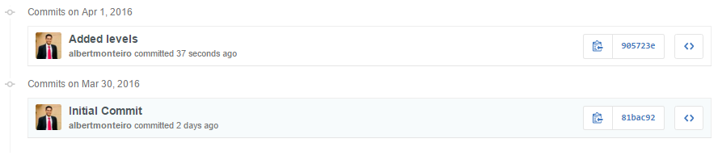

1. **Game Overview**

The goal of the game is to get to the end of each level in order to get to the next level. Once you complete all 3 levels the game is over.

1. **Game Play Mechanics**

N/A

1. **Camera**

The camera follows the player in this game.

1. **Controls**

Use the direction keys on the keyboard to control the player.

1. **Saving and Loading**

N/A

1. **Interface Sketch**

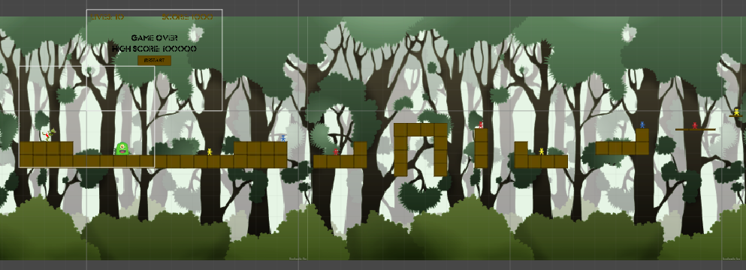

**Level 1**

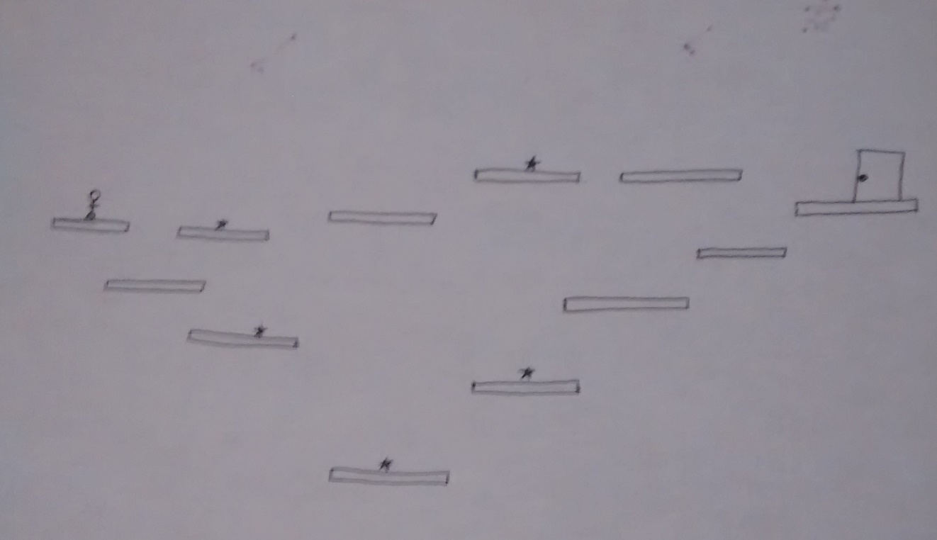

**Level 2**

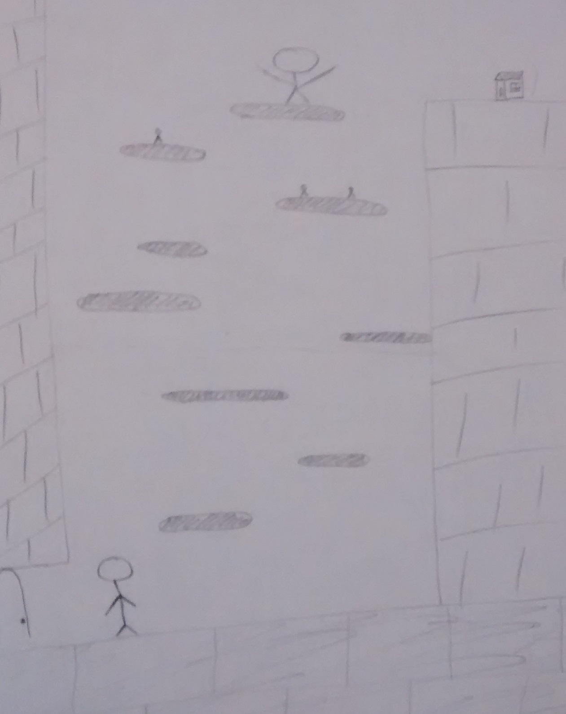

**Level 3**

1. **Menu and Screen Descriptions**

N/A

1. **Game World**

This is a “platformer” type of game.

1. **Levels**

This game will have 3 levels.

1. **Game Progression**

N/A

1. **Characters**

TBD

1. **Non-player Characters**

TBD

1. **Enemies**

TBD

1. **Weapons**

TBD

1. **Items**

The enemies must be avoided or the player will lose lives.

1. **Abilities**

Move around and jump.

1. **Vehicles**

N/A

1. **Script**

This game is written in C#.

1. **Scoring**

You collect the “point” elements to gain points.

1. **Puzzles/Mini-games**

N/A

1. **Bonuses**

TBD

1. **Cheat Codes**

N/A

1. **Sound Index**

|  |  |  |
| --- | --- | --- |
| **Name** | **Author** | **Source** |
|  |  |  |

1. **Story Index**

TBD

1. **Art / Multimedia Index**

|  |  |  |
| --- | --- | --- |
| **Name** | **Image Preview** | **Source** |
|  |  |  |

1. **Design Notes**

N/A

1. **Future Features**

TBD

1. **Links**

Github: <https://github.com/albertmonteiro/COMP305-Project>